


- Range 7Mhz - 430Mhz.
ENG
Wide Band Portable Antenna
HF-PRO-1
- 1/4 wave (50/144MHz), 5/8 wave (144/430MHz)
- You can also use the antenna as 1/4 wave (144Mhz)
- To use this antenna properly, read this instruction thoroughly before using it. This antenna (7-430Mhz) is designed exclusively for amateur radio, communication only.
- Keep this manual carefully at hand for later use.

Notes for Using the Antenna

To avoid accidents, follow the below notices

- This antenna is designed to use the car body or the metal handrail as the ground earth when the portable use. Do not install the antenna fixed and on to the transceiver all the time due to the issues of the product strength and waterproof. This antenna is prohibited from using for mobile, due to this antenna is not prepared for strong winds.
- Do not touch the antenna during transmission. Touching the antenna during transmission may cause to electrify depending on the power used.

Description

- The HF-PRO-1 can be operated on wide band 7-430MHz. lt is OK to use the HF-PRO-1 only when portable operation.
- If the frequency adjusted is a higher value, lower the rod element.
- 144MHz band can be operated at both 1/4 wave and 5/8 wave depending on the length of the additional element used.

Specification

Frequency | 7-430 MHz Band
Max. Power Rating | 130W (SSB)
Impedance | 50 ohms
Length | 0.5-1.77m
Weight | 300gr
Connector | PL
Type | 1/4 wave reduced type (HF Band). 1/4 wave (50/144MHz), 5/8 wave (144/430MHz)  *144MHz band can be operated at both 1/4 wave and 5/8 wave by the length of the rod element.
Accessory | Additional Elements (Short/Large)

Adjustment
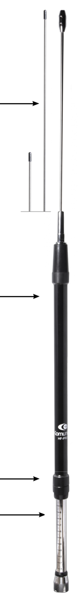
- Select the right frequency, check the position of the antenna body scale with the graphic or the band chart Fig.1 & Fig.2
- Loosen the set screw as a half turn by hand. (Keep the rod element retracted).
- Slide the antenna body to the request frequency after step 1 and fasten it with the set screw by hand. Make the rod element full length.
(Do not use any tools such as pliers when fasten set screw. The antenna may be damaged).
- Transmit and measure the SWR. lf the tuning frequency is lower than the request frequency, make the rod element short or make the antenna body down.
The SWR should be lower than 1.5 depending on the conditions. If not, please change the installation conditions. We also recommend using the antenna tuner.
- lf the tuning frequency is higher than the request frequency, move the antenna body up.
- When adjusting 50MHz band, put the antenna body down and make the rod element full length. (Large radial element).
- When adjusting 144/430MHz bands, put the large radial (Large radial element) in the fixed antenna and fasten the radial element. When adjust 144MHz band, shorten the antenna body 1/4 wave, change the radial element of the body antenna to the shorter one (Short radial element). When adjusting 430MHz, make the antenna body retracted with the large radial element (Large radial element).
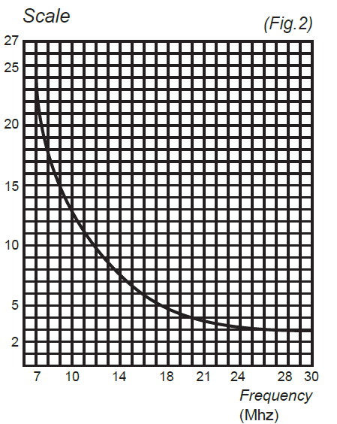

Rod Element
Radial Element
(Additional Large/Short)

In Installation (example)

- Set the bracket where the grounding earth can be taken. (gutter mount, trunk lid etc.)
- lnstall the antenna at the car roof by the magnet base.
- Set the magnet base on the wood table and install the antenna with approx. 10m ground wire and connect to the grounding earth.
- Install the antenna at the metal handrail where the grounding earth can be taken.

Antenna Body

HF-PRO-SERIES Accessories:

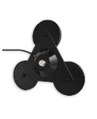
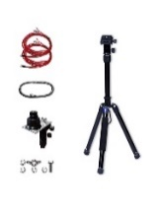
Caution
TRIPLE-MAG
Magnetic base
with triple magnet
maximum adherence
3pcs x 9cm
Connector: SO-239
Cable RG-58 (5mts)

HF-MAG
7 ~ 50MHz Magnetic Ground Plane Attachment
TRIPOD-KIT
Telescopic Tripod Extendable 5 sec.
Please install the antenna vertically to have a better performance.
The SWR should be lower than 1.5 depending on the conditions. In that case, please use the antenna tuner.

(Fig.1)

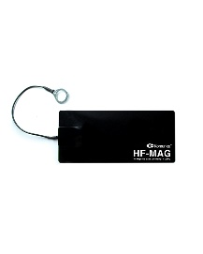

Settings of HF PRO 1
Frequency | Scale (mm)
30.000 | 3
29.000 | 3
28.000 | 3
24.900 | 4
21.300 | 4
18.000 | 5
14.100 | 8
10.500 | 16
7.040 | 24

Set Screw

Design and specifications of this antenna can be changed at any time without previous notice.

Scale
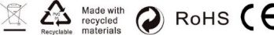
Errors and omissions excepted (E&OE)

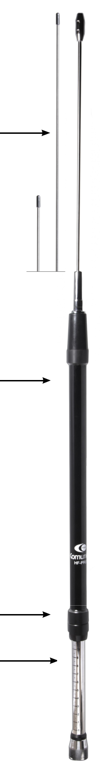

Errores y omisiones exceptuados (E&OE)

